Grade 7 Accelerated · Unit 4 · Lessons 2–3  Multiplying and Dividing in Scientific Notation  Question Bank - Additional 4.02 ANSWER KEY | Name  Date  Period

Show your work. Circle your final answer.
For questions 1 through 6, multiply or divide. Write each answer in scientific notation.
1. 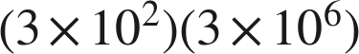


2. 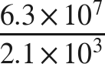


3. 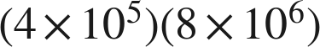


4. 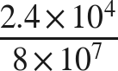


5. 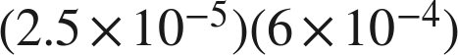


6. 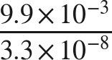

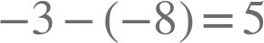.

Real quantities.
7. The Amazon River discharges about  gallons of water every second.
a. About how many gallons does it discharge in one hour, which is  seconds?
about  gallons
, so the product is  before it is finished.
b. A second river discharges about  gallons per second. How many times larger is the Amazon's rate?
5 times larger

8. A factory produces about 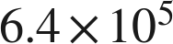 bottles per day.
a. How many bottles does it produce in 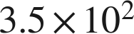 days?
 bottles
.
b. A second factory produced  bottles in 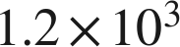 days. How many bottles per day is that?
 bottles per day

Working backwards.
9. Find the missing number in each equation.
a.
n = 7
.
b. 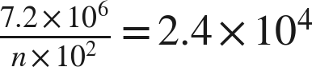
n = 3
.
c. 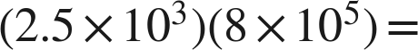 ______

The coefficients multiply to exactly 20.

Reading someone else's work.
10. Dana divides 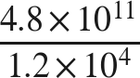 and writes . Name her mistake and give the correct quotient.
She subtracted the coefficients instead of dividing them. The power of ten is right. The correct quotient is .
, which is where her coefficient came from; .

11. Which is the value of 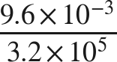 ?
● A. 
○ B. 
○ C. 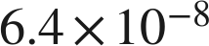
○ D. 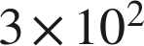
A

12. Select ALL of the expressions whose value is 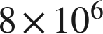.
☒ A. 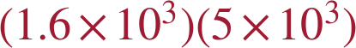
☒ B. 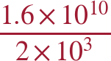
☐ C. 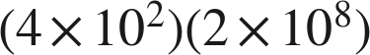
☒ D. 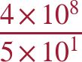
☒ E. 
☐ F. 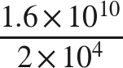
A, B, D and E
B and D each give , which is  once it is finished.

